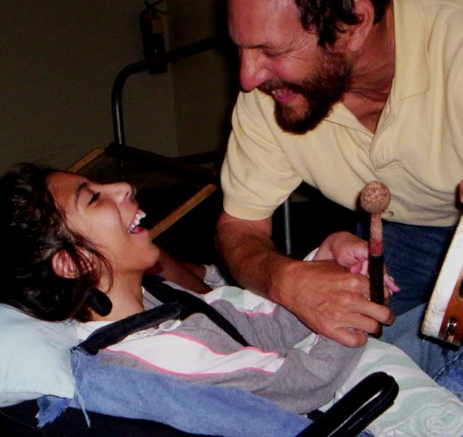
Dr. Laz: Hero To The Disabled
By: Elliot Resnick, Jewish Press Staff Reporter
January 30, 2008
Dr. David Lazerson, or Dr. Laz as he is affectionately known, recently won the second Teacher of the Year award of his career – and for good reason. Over the last several years he has brought joy and cheer to scores of profoundly disabled children at The Quest Center in Broward County, Florida, the nation’s sixth largest school district.
Every school day Dr. Laz plays guitar, sports a wide smile and does practically anything – including tripping over garbage cans and walking into walls – to get his pupils’ faces to shine. Some students sing along as he plays; others accompany him as best as they can on percussion instruments while others do so via adaptive switches that they regulate with their hands, feet, and heads – whichever body part they can best control. One student is connected to a bubble machine.
"I try to make it as experiential as possible," Lazerson said. "My whole philosophy of education is to turn students from passive observers into active participants."
In line with this credo, Lazerson formed the unique Sing and Sign choir, which performs for schools and senior centers. He sings while his "choir" joins him by forming pre-rehearsed hand motions and signs. Sometimes his students dance with members of the audience.
The choir and the crowds are delighted, Lazerson said. "The performances break the tremendous stereotype that these children can’t contribute."
He has even arranged, when possible, for the students to serve as teacher assistants or as tutors to younger children. Peer tutoring, or the chavrusah system is "the most authentic Jewish method of learning," Lazerson said. He wrote both his Master’s and Ph.D. theses on the chavrusah method, and recently published a research paper on the subject.
While Lazerson is now part of the Chabad-Lubavitch chassidic movement, this was not always the case. He discovered traditional Judaism while a senior in college. After graduation, a three-day experiment at the Rabbinical College of America in Morristown, New Jersey, lasted three years.
Lazerson’s faith helps shape his view of disabled children. In one particular chassidic tale that Lazerson likes to recount, the saintly Rabbi Levi Yitzchak of Berditchev stands up as a mentally retarded man walks by. When queried by his followers, Rabbi Levi Yitzchak says, "That man has lived for 40 years without ever sinning; how could I not stand up?"
Lazerson’s career has been colorful. In 1981 he won his first Teacher of the Year award for his work with inner city black children in Buffalo (the subject of his first book, Skullcaps ‘N Switchblades).
Drawing on that experience, Lazerson, together with Rev. Paul Chandler, helped promote racial harmony between the Jewish and black communities after the 1991 Crown Heights riots. The duo formed Project CURE (Communication, Understanding, Respect, Education), which included a Jewish-black band and a Jewish-black basketball team.
A 2004 Showtime-produced TV movie "Crown Heights" told this story, with Howie Mandel (of NBC’s "Deal Or No Deal") playing Dr. Laz.
In addition to teaching, Lazerson currently performs concerts, gives lectures, and is in midst of writing his fourth book, tentatively called Singing With Angels.
His work recently earned him Distinguished Alumni awards from Buffalo State University and the University of Buffalo.
While Lazerson’s activities have varied over the years, the motivation behind them appears to be the same: a love of humanity. "Growing up," Lazerson said, "I never heard my parents speak badly of someone. They befriended anyone and everyone regardless of their size, shape, and color."
The Talmud relates that Elijah the Prophet once singled out two men to Rabbi Beroka and said these two were assured a place in the world to come. When Rabbi Beroka asked the men about it, they told him they were jokesters who lift up people’s spirits and dispel tension with humor.
"I think of that story a lot," Lazerson said. "These kids have been dealt a pretty poor deck. I just try to bring some smiles to their faces…. It’s the greatest job in the world."

