Sun-Sentinel
Broward County Edition
Special-needs students at Quest Center in Hollywood present stage show

Personalities shine through music

By Marcia Freidenreich | Special Correspondent

June 1, 2008

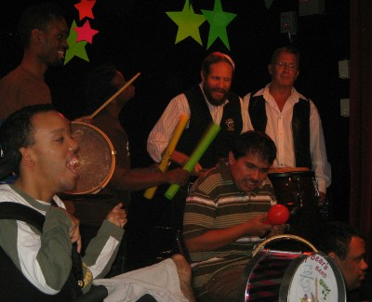
Dr. David Lazerson, second from right, who was
recently selected for induction into the National Teachers
Hall of Fame, leads his special needs drum/percussion group.

Special-needs students at the Quest Center in Hollywood belted out tunes, danced to music by Beyonce Knowles and played musical instruments during an end-of-the-year talent show. The students, who have Down syndrome, cerebral palsy, autism and other needs, sang and danced on stage. Students confined to wheelchairs operated lighting, visual and special percussion effects using adaptive switches.

Yusupha Betts, 16, used his knee switch to activate a special communication device to play his part in a duet with teacher Deborah Kelly, of Hallandale Beach.

"The show was more about the process than the final product," said David Lazerson, the center's director of music therapy, who holds a doctorate in educational research and evaluation.

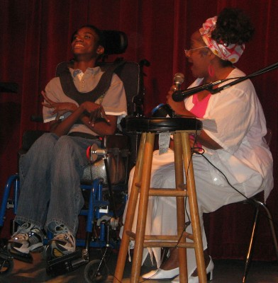
Yusepha Betts, 16, and teacher Debra Kelly
perform a duet at the Quest student talent show.

"Its purpose was to get them involved using a fun medium like music. Having them operate percussion instruments or lighting, for example, teaches them cause and effect."

Lazerson, who was recently named to the National Teachers Hall of Fame, said the show helped bring out the personalities of some of the quiet and shy students.

"They surprise us all the time," he said.

One girl sang a solo Disney song, and another sang and danced to a rousing number by Knowles.

"They are suddenly rock stars," Lazerson said.

The Quest Center, a Broward County school, is at 6401 Charleston St., Hollywood.

Photos by Marcia Freidenreich

